Recommended practice for mass trapping of Douglas-fir beetle, Dendroctonus pseudotsugae.

Objectives
- Absorb Douglas-fir beetle (IBD) adults emerging from nearby currently infested Douglas-fir (Fd) and reduce attacks on adjacent susceptible Fd.
- Compliment fall & burn, or deployment of trap trees.
- Mop-up after sanitation harvesting.

Efficacy
- Shore et al (2005) estimated that it takes about 1700 beetles (850 females + approximately 850 males) to kill a tree. Without trying to account for a skewed sex ratio in traps, it can be estimated that 100,000 trapped beetles reduces nearby infestations by about 59 trees.

Advantages and disadvantages

Advantages
- Can be used in areas where logging and/or felling and retrieval of trap trees are not possible because:
  - Major licensees are not operating in the infested area;
  - There is no current market for small scale salvage operations;
  - Terrain is inoperable or outside the timber harvesting land base; or,
  - Infested area has other values, e.g., mule deer winter range, old growth reserve, recreation trails, First Nations, etc.
- Serviced funnel traps do not become “saturated” (unlike trap trees) and can continue to capture beetles throughout the flight period.
- They can be used in conjunction with MCH repellent in a “push-pull” operation.

Disadvantages
- Requires dedicated crew from April 1st- August 15th.
- Access may be difficult on some roads in early April.
- Requires servicing weekly or bi-weekly depending on flight density.
- Occasional damage by delinquent bears.
- Not as attractive as trap trees?
- Can be higher cost than trap trees.

Figure 1. Three trap set of baited funnel traps.
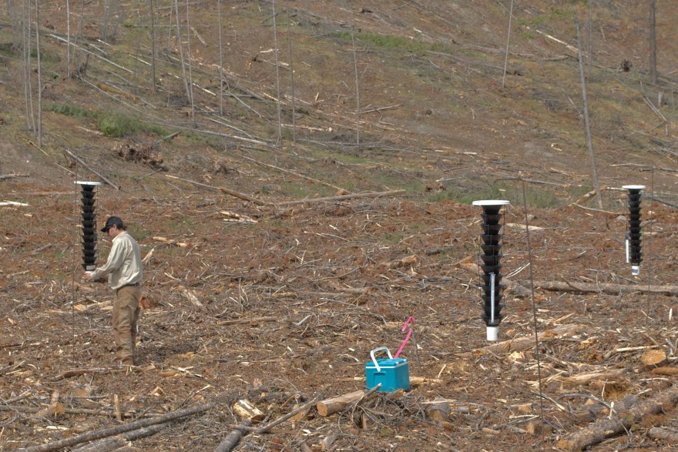

Figure 2. Lure placement on funnel trap . Figure 3. Vapour tape placement in “dry” cup.
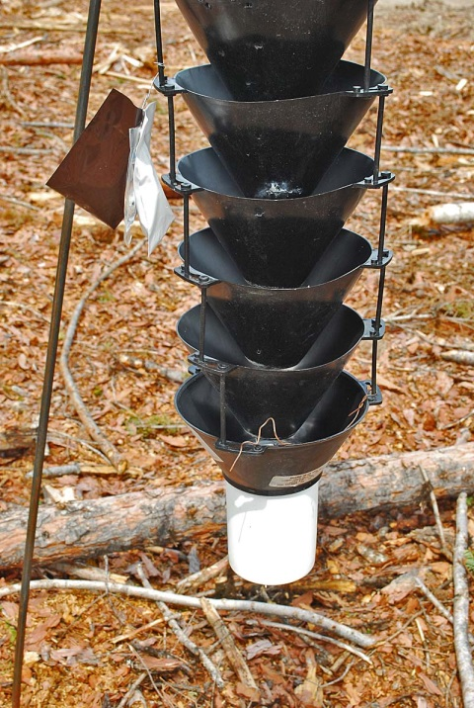
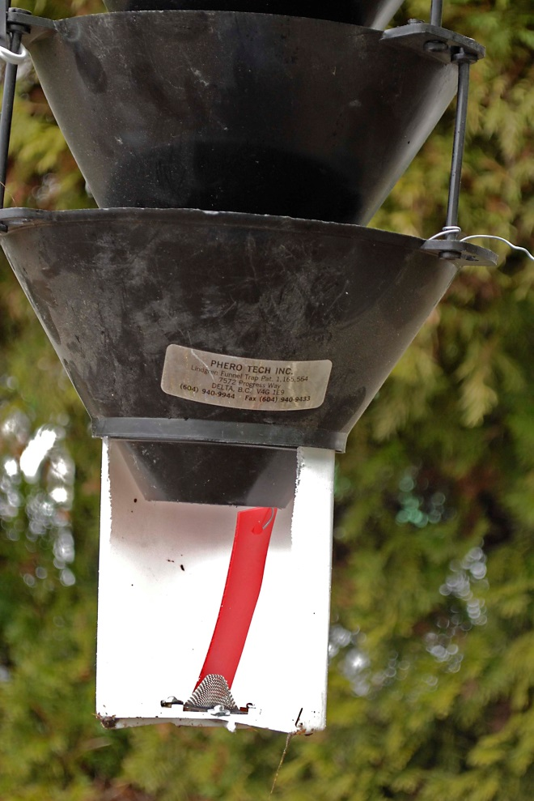

Set-up guidelines
- Use a 3-trap triangle of baited Lindgren funnel traps, with inter-trap spacing at 5 -10m. This approach was developed by Ross and Daterman (1997) (Figure 1). See the checklist for equipment (Table 2).
Possible increases in efficacy associated with increasing or decreasing the number of baited traps, or varying the trap configuration (e.g. line vs. triangle) have not been systematically investigated. A “quad” trap configuration consisting of a central baited funnel trap surrounded by a triangle of 3 unbaited funnel traps at 1 to 2 m distance was investigated by Laidlaw and Wieser (2002) and recommended for operational use (Laidlaw and Wieser 2002, BCFS 2000). However, the “quad” configuration actually presented a likelihood of significantly increased cost without a clearly demonstrated increase in efficacy. As such, use of the “quad” configuration (or any other unproven combination of baited and unbaited traps), is unacceptable. (see Appendix 1).
- Trap sets must be at least 100 m from Fd in susceptible stand edges.
- Trap sets in cut blocks should be at least 100 m from standing residual trees, and even then standing trees ≥ 30 cm should be protected with MCH.
- Maintenance weekly, and then possibly every 2 weeks as flight declines depending on trap catch.
- Trap sites exposed to knockdown by animals can be protected with “Critter Gitter Alarms”, 2 - 3 per site.
- Hang lures on the outside of standard Lindgren funnel traps (Figure 1), about 1/3 or ½ height (Figure 2). Follow manufacturers recommendations if using highly modified traps from Synergy Semiochemicals.
- Lures should be replaced in the second or third week of June.
- A “dry cup” set up is easier to maintain and environmentally more manageable than “wet cups”. Use vapor tape dichlorvos dispensers (see Table 1) to kill beetles in cups. Ensure the tapes are vertical in the cup (Figure 3).
- Choose locations having IBD populations threatening adjacent susceptible Fd. Factors influencing placement: BMU strategy, stand hazard ratings, current infestation levels, harvesting plans, recent blowdown, and possible use of trap decks or trees.
- Move trap sets that are not catching any beetles to different sites or to a current site that is catching lots of beetles.
- Keep traps reasonably proximal to established roads to enable trap establishment and servicing, but far enough away from roads to avoid serious coverage by dust.
- The easiest (fastest?) way to count trapped beetles is by volume. For estimates, approximately 1100 + 35 (SD) adults occupy 50 ml for cleaned and dried samples. However calibrated weight can also be used.

Table 1. Comparison of funnel trap collecting cup “kill” options.
Propylene glycol | No-pest strip* | Vapor tape*
Recreational vehicle plumbing anti-freeze. Used with “wet cups” (with rubber stopper in bottom drain hole and screened side drains) | “Rubber” bar about 2 in wide x 6 in long x 3/8 in thick, available at Home Hardware (Home Defense Max, others?). About 10 pieces per 65 gram bar. Price as of March 2016 = $14.49/bar = about $1.49 per piece. | 50 unit packs of Individually wrapped tapes about 4 in long x 1 in wide x 1/8 thick. Current price as March 2016 = $4.20 per piece.
Can be diluted 50:50 with water for cup refills. | Relatively cheap to purchase | Expensive
Requires “wet cup”, fill 1/3 to ½ full. | Requires “dry cup”. Dichlorvos “Domestic” formulation | Requires “dry cup”. Dichlorvos. May not be available in near future
Must be replaced after each collection (assuming 1 or 2 week collection period). | Requires handling to make and install in traps. Bars must be cut to piece size, and then set with wire (18 ga), then fit in trap. | Wire hang holes are pre-cut in tape. Easy to use. Easy to set so that the depth of the cup is exposed to tape even as cup fills with beetles (Figure 3)
Use strainer (a conical paper paint filter with a nylon or woven cotton screen in the bottom?) over funnel over jug to collect used fluid | Requires monitoring to ensure continuing efficacy. | Requires monitoring to ensure continuing efficacy**. Observations suggest that mid-season replacement is not required.
Used fluid must be properly disposed of (at RV sales/service location?) | Easy disposal at end of field season (garbage) | Easy disposal at end of field season (garbage)
Field spill procedures required. | Relatively safe to use and store | Tapes are individually wrapped so quite safe to transport and store. Easy to use.
DO NOT USE Ethylene glycol (automobile coolant) | Requires that collected samples be stored in freezer 24-48 hrs to ensure all beetles are killed | Requires that collected samples be stored in freezer 24-48 hrs to ensure all beetles are killed
Requires pesticide grade rubber gloves for handling, available at farm supplies or hardware stores | Requires pesticide grade rubber gloves for handling, available at farm supplies or hardware stores | Requires pesticide grade rubber gloves for handling, available at farm supplies or hardware stores
Considered a preservative so fully legal | Not federally registered for this use. | Not currently federally registered for this use, but a User Requested Minor Use Label Expansion (URMULE) is in progress as of August 2016.
* Not currently registered in Canada for this use.
** The manufacturer suggests "12 weeks" or until "diminished performance is noted". Twelve weeks is about 3 months, and we need about 4 or 4.5 months (April, May, June, July, 1/2 of August).

Table 2. Douglas-fir beetle funnel trap equipment checklist_v2 (29 April 2014):
√ | Item | Required Quantity | Cost per unit | Total cost
 | Location maps and coordinates
 | Funnel traps with hanger wires and “dry cups” (for Vapona) or “wet cups” for polypropylene glycol, with a few spares
 | Lures, including June replacement
 | Vapona or polypropylene glycol
 | Trap hangers, rebar, 1/2" conduit, or sapling pole tripod. Specs available
 | 2 litre plastic container to refill polypropylene glycol | 1 per crew
 | MCH to protect single standing trees within 200 m of trap sets
 | Critter Gitter alarms w/ 9 volt batteries,spare batteries & small dark bungee cords
 | Heavy wire (14 ga) for spare trap hanger wires
 | Light wire (18 or 20 ga) for spare lure hangers and Vapona hanger
 | Steel pipe (3/4” x 2’) for making trap hanger holes in ground. | 1 per crew (plus)
 | Laminated signs to hang on traps
 | 50 and 100 ml graduated cylinders (for lab use only)
 | Counting record forms and xls spreadsheet (for lab use only)
 | Field book to record any notable info. re: each site
 | GPS units | 1 per crew
 | Large contractor grade garbage bags to transport traps, lures, vapona & misc. supplies into each site
 | Rubber or vinyl gloves
 | Jug of clean water and soap for hand washing
 | Lineman pliers
 | 1.5 or 2 lb mallet or sledge hammer | 1 per crew (plus)
 | Ziplock freezer bags (large, medium and regular) or 50 ml plastic specimen bottles & permanent black marker pens. Small paint brushes to aid transfer of beetles from selected cups to containers for calibration of trap efficacy.
 | Cooler and freezer packs for baits
 | Flagging tape
 | Scissors or box cutters for opening vapona packs
 | Ruler (metric)
 | Camera to record variety of collection cup captures & record any bear damage
 | Offsite domestic quality freezer to store collected beetles, baits, lures, etc.
 | Duct Tape, Zip ties, flagging tape, spare trap parts
Trap maintenance contract, persondays
1/week in April + mid-July +August. 2/week May-June-early July
 | Beetle counts contract, persondays

Estimating IBD trap catches:
Sample the “northern -most” trap in each 3-trap set. Sample weekly until flight starts to decline in late June-early July, then every 2 weeks is OK, although trap sets with recurring knockdowns should be checked weekly.

Pheromone and vapor tape suppliers

Recommended supplier of Douglas-fir beetle funnel trap lures as of August 2016:

Synergy Semiochemicals Corporation
synergy@semiochemical.com
phone 604-454-1122 or 604-568-8501
fax 604-568-8502

The recommended lure is Douglas-fir beetle high potency (“enhanced”).

The recommended (only) supplier for vapor tapes is:
WestGreen Global Technologies
net2officebthomson@shaw.ca
Phone (778) 298-8798

Suppliers for funnel traps and parts, and MCH :
Both Synergy and Westgreen can supply funnel traps. Westgreen can supply MCH.

Art Stock, Ph.D., RPF., Forest Entomologist, Kootenay-Boundary Region, MFLNRO
Phone: 250-354-6911 Cell: 250-551-1458, Art.Stock@gov.bc.ca

With contributions from:
Jodi Axelson
Robert Hodgkinson
Bernie Hulstein

References
BCFS. 2000. Douglas-fir bark beetle history and management in the Invermere Forest District. BC Forest Service, Invermere, Unpublished Draft, 25 January 2000. 13 p.
Dodds, K.J., D.W. Ross, and G.E. Daterman (2000). A comparison of traps and trap trees for capturing Douglas-fir beetle, Dendroctonus pseudotsugae (Coleoptera: Scolytidae), J. Entomol. Soc. B.C., 97: 33-38.
Laidlaw, W.G., and H. Wieser. 2002. An effective strategy for trapping Douglas-fir beetle, Dendroctonus pseudotsugae (Col., Scolytidae) using combinations of unbaited and pheromone baited funnel traps. J. Appl. Ent. 126, 143–147.
Laidlaw, W.G., B.G. Prenzel, M.L. Reid, S. Fabris, and H. Weiser (2003). Comparison of the efficacy of pheromone-baited trees and felled trees for the control of Dendroctonus pseudotsugae (Coleoptera: Scolytidae). Environmental Entomology: Vol. 32, No. 3, pp. 477-483.
Ross, Darrell and G. E. Daterman. 1997. Using pheromone-baited traps to control the amount and distribution of tree mortality during outbreaks of the Douglas-fir beetle. For. Sci. 43: 65-70.
Shore, T.L., W.G. Riel, L. Safranyik and J. Castonguay. 2005. Survival of the Douglas-fir beetle in peeled and unpeeled logs and in stumps. West. J. Appl. For. 20(3):149 –153

Appendix 1. Comparison of estimated cost and efficacy for 1, 2, and 3 baited funnel traps, and a “quad” formation of 1 baited funnel trap with 3 unbaited satellite funnel traps, for mass trapping of Douglas-fir beetle.

The experimental design used by Laidlaw and Weiser (2002) in developing the “quad” trap set for Douglas-fir beetle trapping tested 1 baited trap against one baited trap surrounded by 3 unbaited traps . However, Laidlaw and Weiser (2002) failed to test the obvious logical hypothesis that 2 baited traps might catch as many or more beetles than either of the tested treatments (Table 1).
Table 1. Summary of total seasonal trap catches of Douglas-fir beetles caught in pheromone baited and unbaited funnel traps arranged in three different configurations in 1998 and 1999, Invermere, T.S.A., Invermere, B.C., and Tree Farm License 14, Parson, B.C., Canada (complete data set from Laidlaw and Wieser (2002))
 |  |  | Catch per site |  | Catch in baited traps |  | Catch in 1 m ring traps
Treatment ª | n | Total seasonal catch | Mean | SE | Mean | SE | Mean | SE
Single baited trap | 12 | 12,396 | 1033 | 322 | 1003 | 322
Quad ring,1m | 12 | 22,308 | 1859 | 402 | 1058 | 255 | 801 | 154
Quad rings, 2 and 5 m | 6 | 13,254 | 2209 | 542 | 927 | 166 | 898 | 225
a ‘One single baited trap’; ‘Quad ring, 1m’: A single baited trap plus ring of three unbaited satellite traps at 1 m (± 0.3 m) from the central baited trap; ‘Quad rings, 1 and 5 m’: A single baited trap plus a ring of three unbaited satellite traps at 1 m and an additional ring of 3 unbaited satellite traps at 5 m from the central baited trap.

Estimated material and overhead costs for 1, 2, and 3 baited funnel traps, and the quad trap sets, are presented in Table 2, under the assumption that baited funnel traps are equivalent in catch. The quad set shows a likelihood of approximately double cost, with fewer beetles caught, compared to the expected efficacy of 2 or 3 baited funnel traps. Laidlaw and Weiser (2002) failed to prove the relative utility of the quad trap set, and their conclusions and recommendations are unjustified.

Table 2. Comparison of estimated cost and efficacy for 1, 2, and 3 baited funnel traps, and a “quad” formation of 1 baited funnel trap with 3 satellite funnel traps, for mass trapping of Douglas-fir beetle.
 |  | Trap capitol cost | Lures per 2016 ^{b} | Estimated maintenance and counting ^{c} | Estimated total cost | Seasonal catch ^{d} | Estimated “cost per beetle”
Overhead per trap ª |  | $100.00 | $12.00 | - | $112.00 | - | -
Single baited trap |  | $100.00 | $24.00 | $100.00 | $212.00 | 12,396 | $0.0181
2-baited trap estimate |  | $200.00 | $48.00 | $150.00 | $324.00 | 24,792 | $0.0151
3-baited trap estimate |  | $300.00 | $72.00 | $175.00 | $511.00 | 37,188 | $0.0137
Quad ring, 1m ^{e} |  | $400.00 | $24.00 | $200.00 | $612.00 | 22,308 | $0.0274
a. Based on estimated actual current operational costs, 2016; b. Assumes re-baiting in mid-June; c. Maintenance and counting is estimated based on number of traps. More traps in a given set reduces cost per trap; d. Actual data from Laidlaw and Wieser (2002), except 2 and 3-trap estimates, which are a simple multiplication of actual single trap data. This estimate does not account for possible synergistic or repellent effects relative to a single trap; e. A central baited trap with 3 surrounding unbaited traps at about 1 m distance from the baited trap (Laidlaw and Wieser (2002)).

